Contents

**Part 1: How to setup a raspberry pi3?** 2

**Part 2: How to backup a raspberry pi3?** 8

**Part 3: How to set up python environment?** 11

**Part 1: How to setup a raspberry pi3?**

* Official documentation

<https://projects.raspberrypi.org/en/projects/raspberry-pi-setting-up>

* What you will need
  1. Hardware
     1. 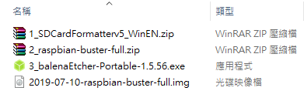Raspberry Pi3
     2. Power supply
     3. A microSD card
     4. A keyboard, a mouse, and a screen
     5. HDMI cable to the screen (If you use VGA, then you have to prepare a HDMI-to-DVI cable)
  2. Software
     1. 1_SDCardFormatterv5_WinEN.zip: format the SD card
     2. 2_raspbian-buster-full.zip: the image for Raspberry Pi3
     3. 3_balenaEtcher-Portable-1.5.56.exe: write an image to the SD card
* Set up the SD card (The version of **Raspbian as image**)
  1. Format the SD card
     1. Download SD Formatter <https://www.sdcard.org/downloads/formatter/index.html>



* + 1. Format the SD card:
       1. Install the formatter
       2. Select card and check “Format”

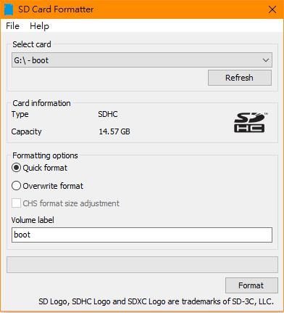

* 1. Download the image
     1. **Raspbian Buster with desktop and recommended software:**
        1. Image with desktop and recommended software based on Debian Buster
     2. <https://www.raspberrypi.org/downloads/raspbian/>

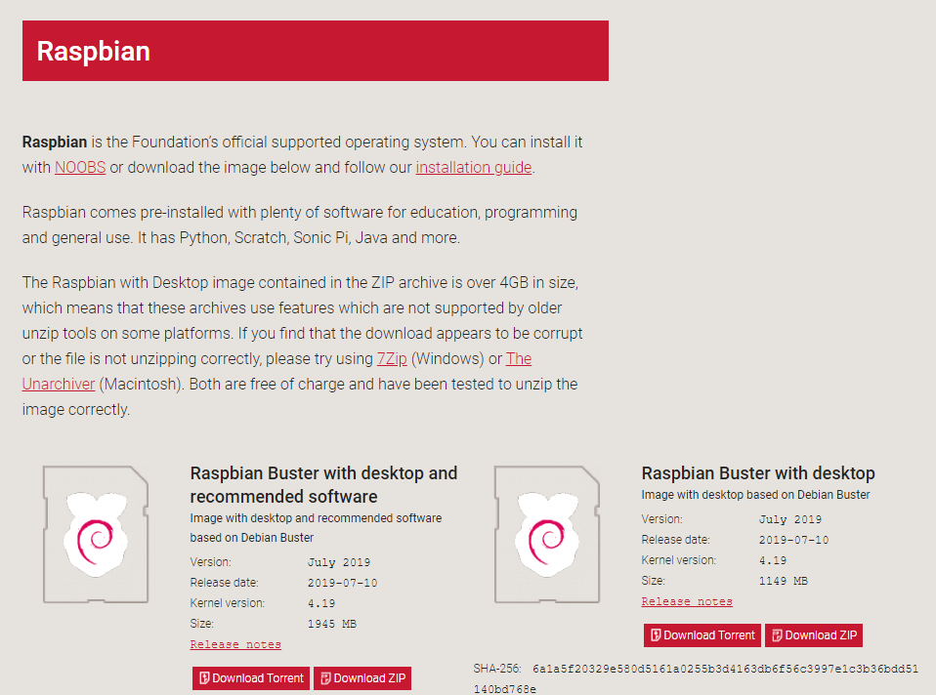

* 1. Writing an image to the SD card by balenaEtcher
     1. Official document <https://www.raspberrypi.org/documentation/installation/installing-images/README.md>
     2. balenaEtcher
        1. Download page: <https://www.balena.io/etcher/>
     3. Write an image to the SD card
        1. Select the image pre-download
        2. Check the device to write
        3. Click “Flesh!”
        4. When it finished, the SD card is OK.

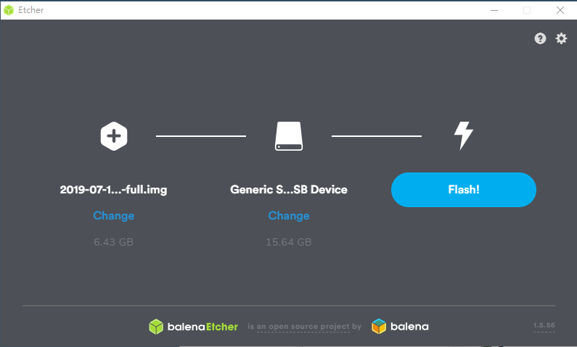

* 1. Editing the config.txt for video output (Before booting up the Raspberry Pi )
     1. Official documentation: <https://www.raspberrypi.org/documentation/configuration/config-txt/video.md>
     2. 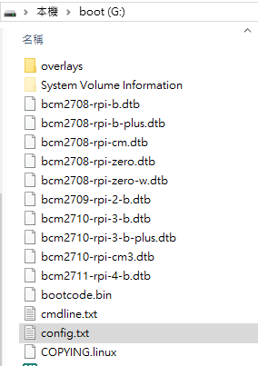Uncomment hdmi_group and set it for DMT (Display Monitor Timings) standard.
     3. Uncomment hdmi_mode and set it for 1024x768 in resolution at 60Hz.
     4. Uncomment hdmi_drive and set it to be normal hdmi mode.
* Start up your Raspberry Pi
  1. Connect the Raspberry Pi

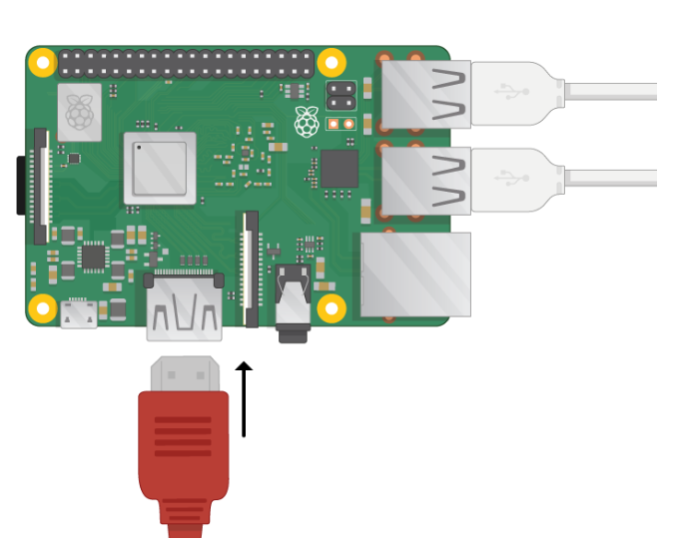

HDMI

Power supply

Mouse and keybroad

* 1. Boosting up



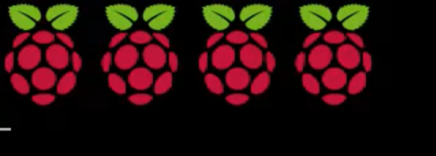

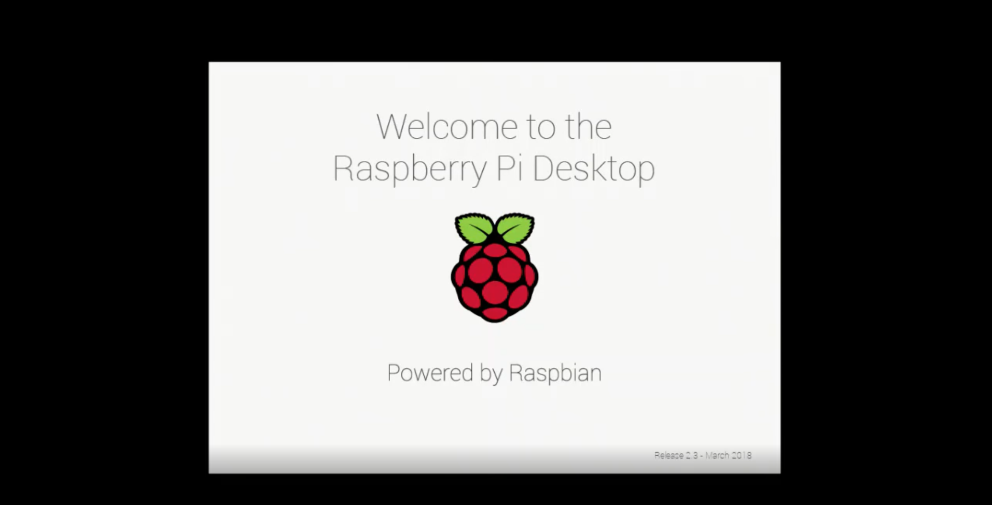

* 1. Get to the desktop
     1. Set up for the pi

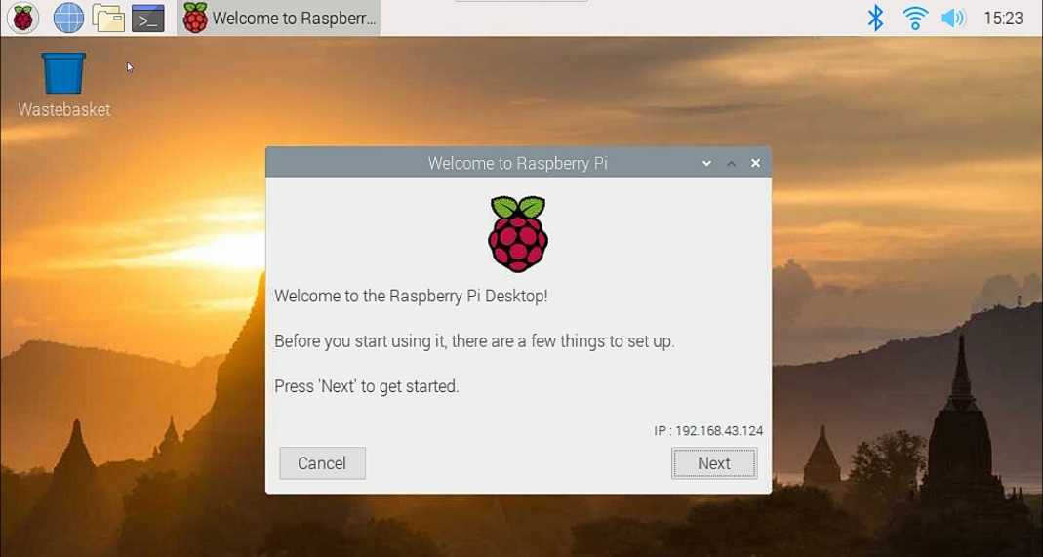

|  |  |
| --- | --- |
| 1 | 2 |
| 3 | 4 |

* + 1. Finish the first set up and restart.

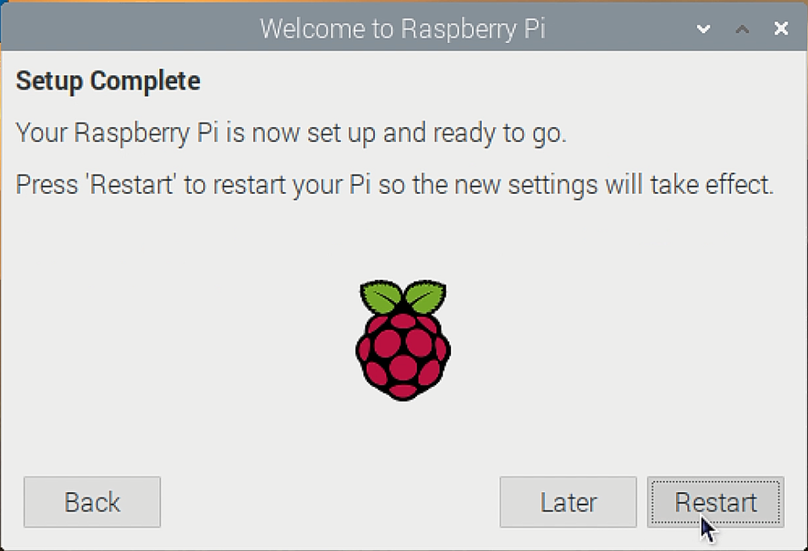

* 1. Some setting if need
     1. Change password <https://www.raspberrypi.org/documentation/linux/usage/users.md>

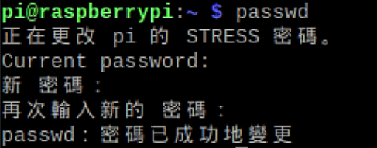

* + 1. Change your keyboard layout <https://thepihut.com/blogs/raspberry-pi-tutorials/25556740-changing-the-raspberry-pi-keyboard-layout>



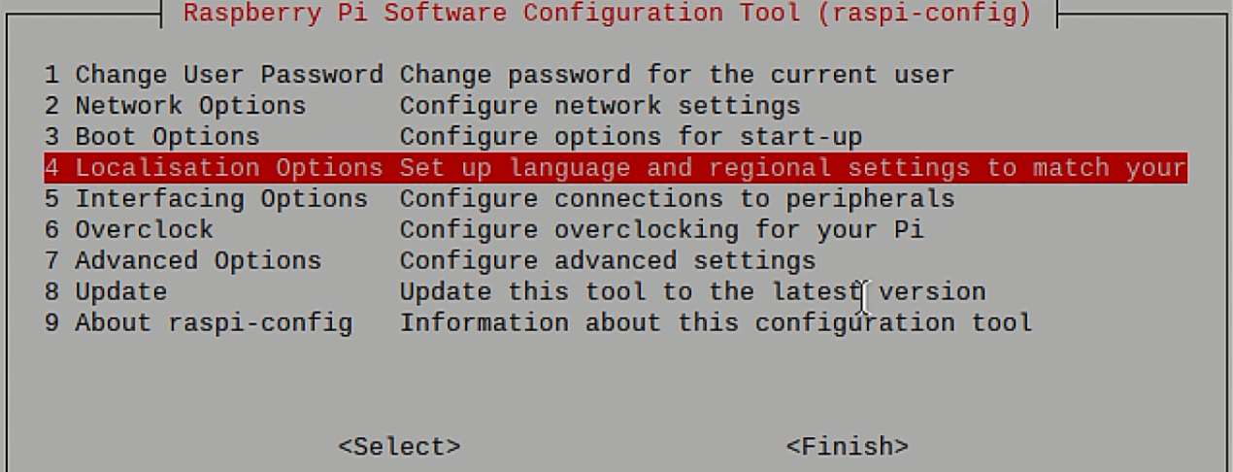

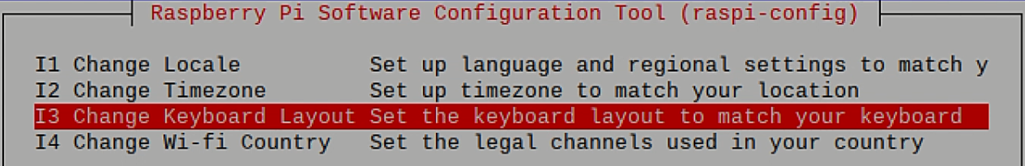

* + 1. Change hostname <https://www.raspberrypi.org/documentation/configuration/raspi-config.md>



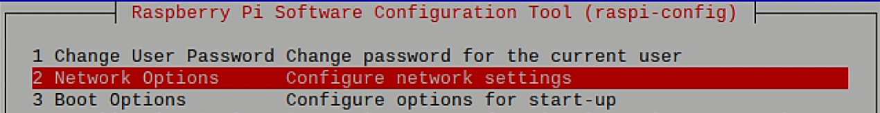

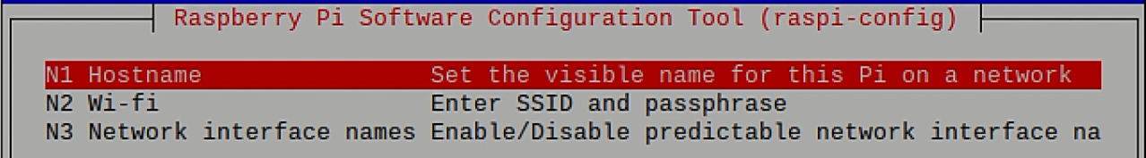

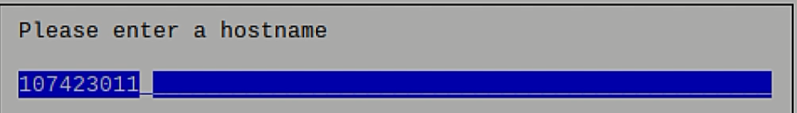

* + - 1. Reboot and check the hostname

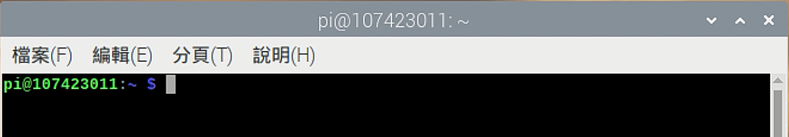

**Part 2: How to backup a raspberry pi3?**

* Tool

Win32 Disk Imager

* Steps
  1. Download the Win32 Disk Imager
     1. Download page <https://sourceforge.net/projects/win32diskimage/>

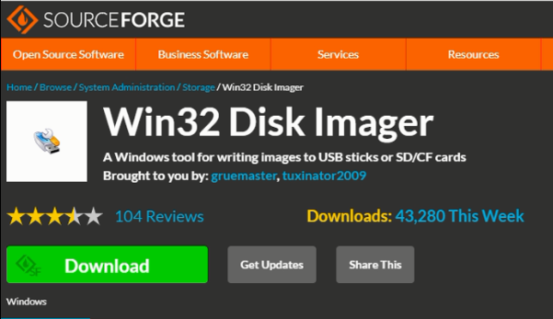

* 1. Install the Win32 Disk Imager

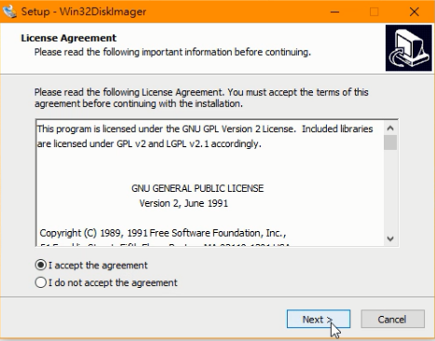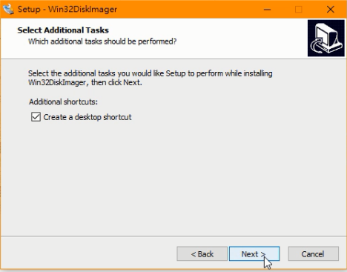

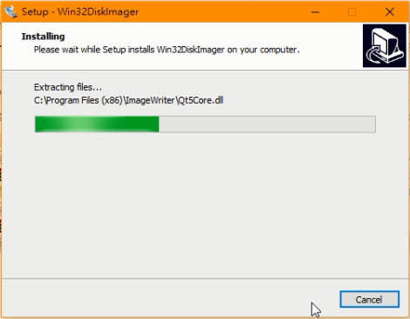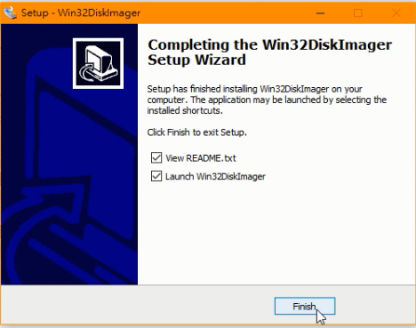

* Check that the SD card is read
  1. If the SD card is read, it would be shown at “裝置”

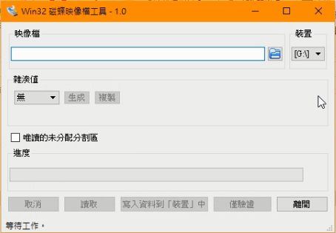

* Choose the place to save the backup file
  1. Note: remember to name with the file format .img

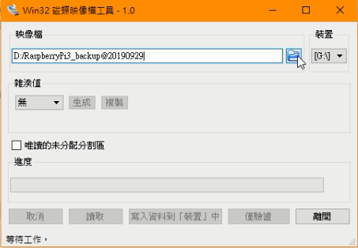

* Check “讀取”
  1. When it finished, the backup is OK.

**Part 3: How to set up python environment?**

* Before we start, add another user as sudor
  1. Official documentation: <https://www.raspberrypi.org/documentation/linux/usage/users.md>
  2. Sudo adduser [username]

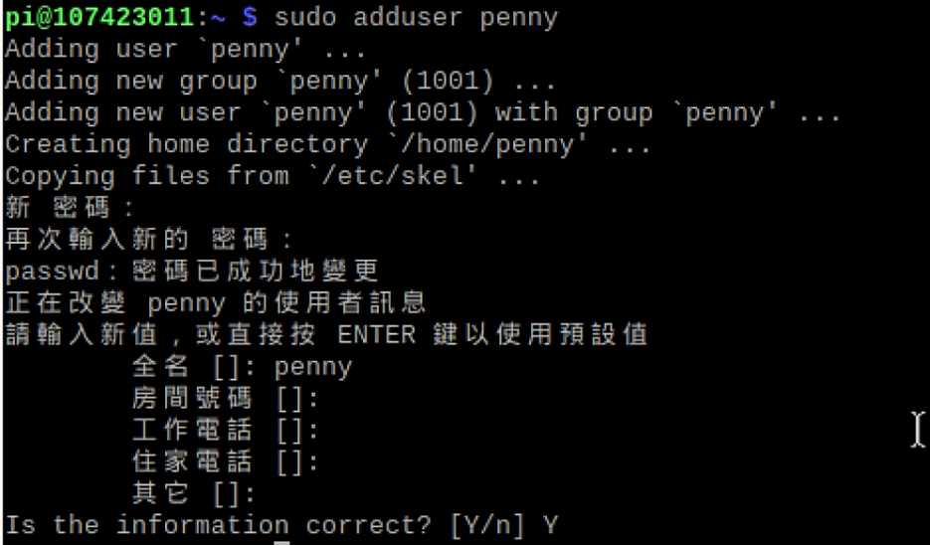

* 1. Give the user passwordless sudo access
     1. Check by let the user do something with sudo

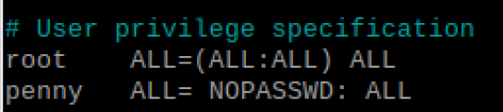

* 1. Change user
     1. Su - [username]: with a “-”, the path change to the user’s path
     2. From now on, be careful of which user is using now

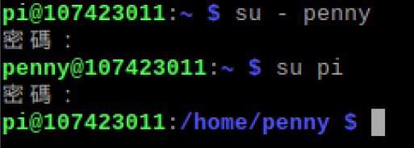

* Install Conda
  1. About:
     1. Conda can install python packages and build virtual environment
     2. There are different kinds of conda, here is the version of **berryconda**
  2. Berryconda should be installed in a user account, not by root or using sudo.
     1. Download Berryconda3
        1. Official documentation: <https://github.com/jjhelmus/berryconda>

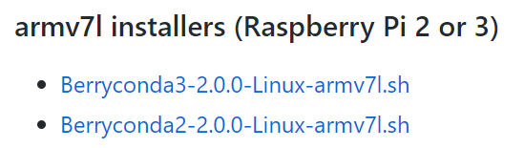

* + 1. You can move it to the path of user account



* + 1. Make the file executable and the execute the installer

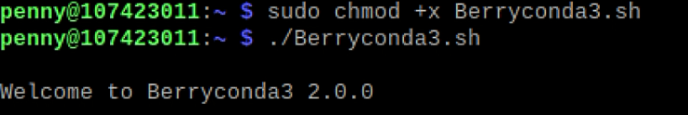

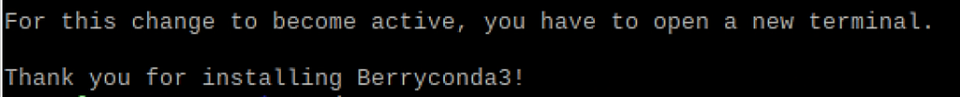

* + 1. Check conda and python version
       1. In user account, the python version become the version installed by conda.

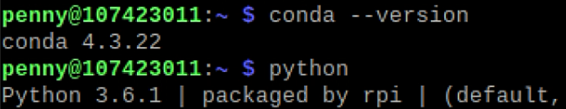

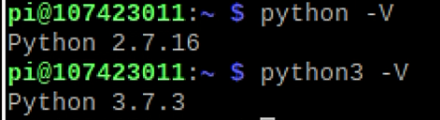

* Install Jupyter
  1. Using conda
     1. <http://www.knight-of-pi.org/installing-jupyter-on-a-raspberry-pi-for-notebooks-debugging-and-data-analysis/>

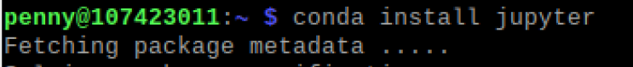

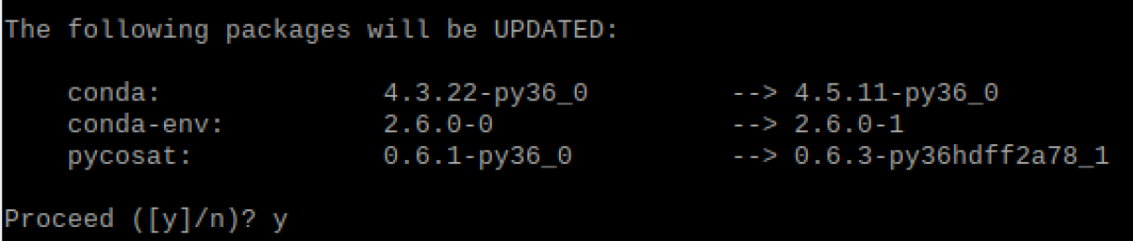



* 1. Get the token and open the browser

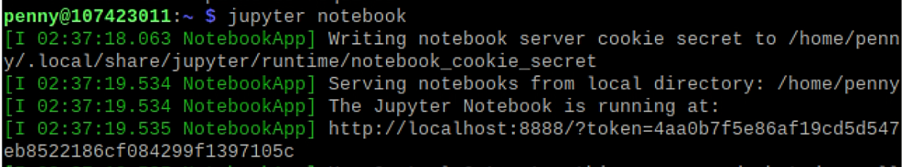

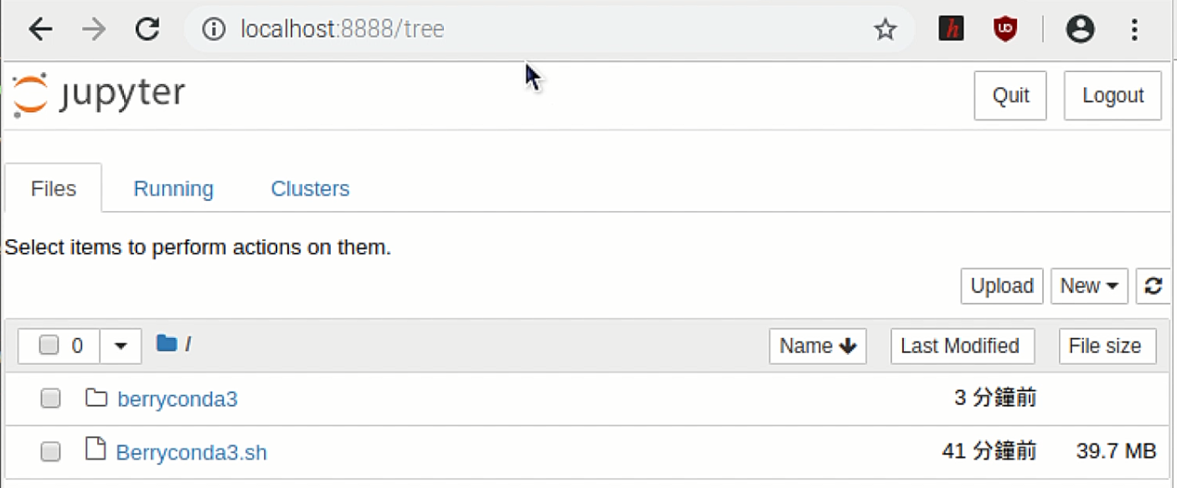

* Create a virtual environment using Conda
  1. conda create -n [environment name] python = [version]

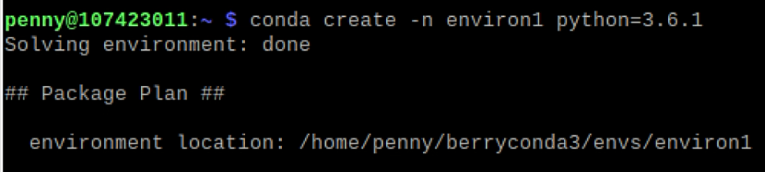

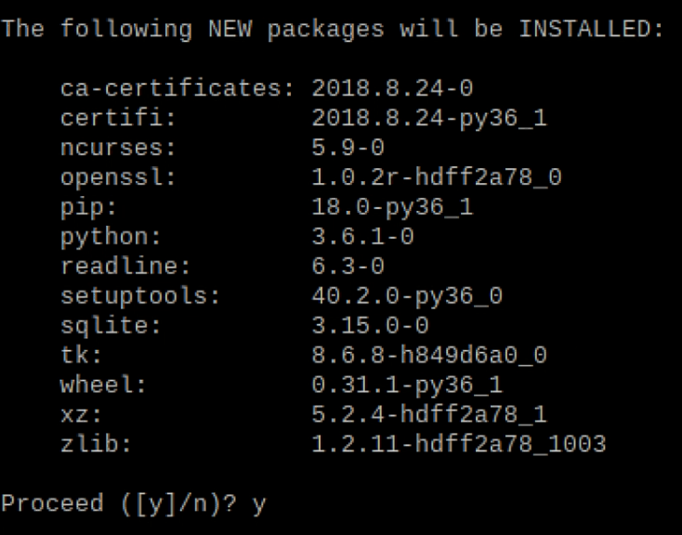

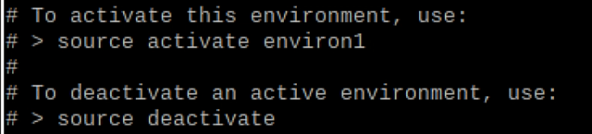

* 1. Activate the environment

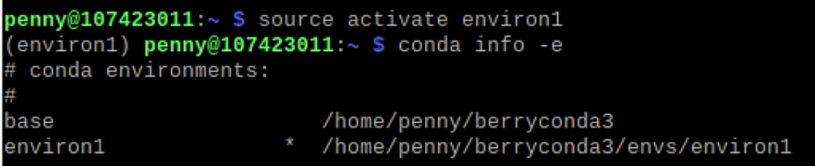

* 1. Install package in the virtual environment
     1. conda install -n [environment name] [package]



* Run a Jupyter Notebook with the above installed packages
  1. Get into the virtual environment
  2. install package nb_conda
     1. for Jupyter Notebook to get the virtual environment



* 1. Run Jupyter Notebook and create a new one with the virtual environment

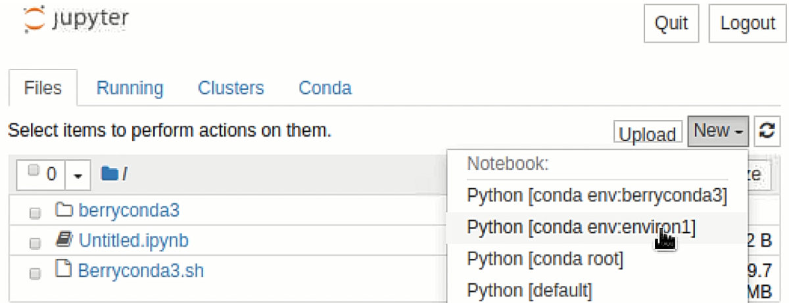

* 1. Check for the virtual environment
     1. package installed in virtual environment only
     2. python version

